ECEN 325

Lab 5: Operational Amplifiers - Part 3

Section 506

02/28/2020

Jason Gilman

TA: Mandela

**Calculations:**

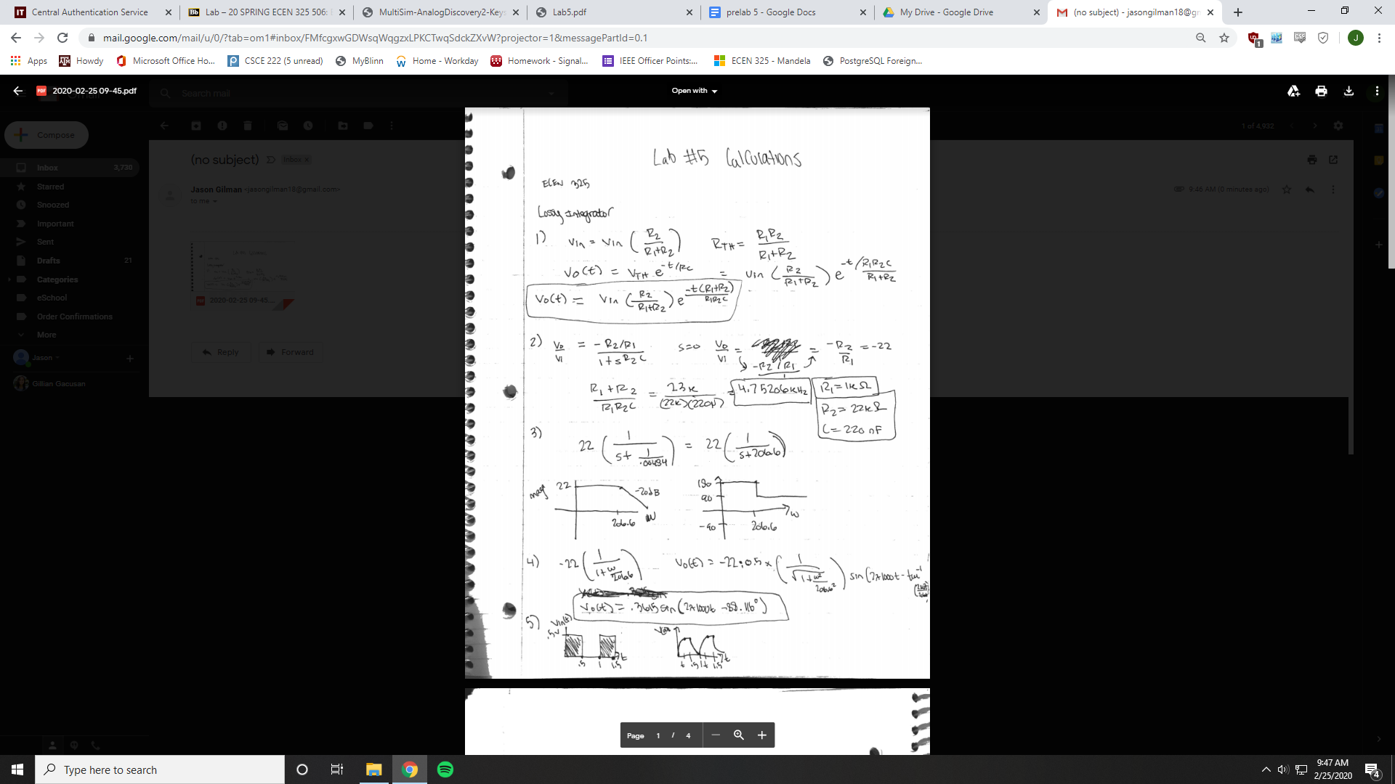

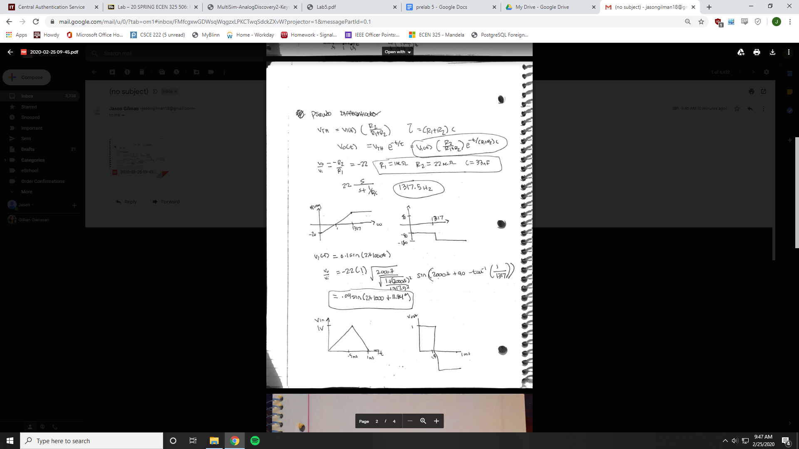

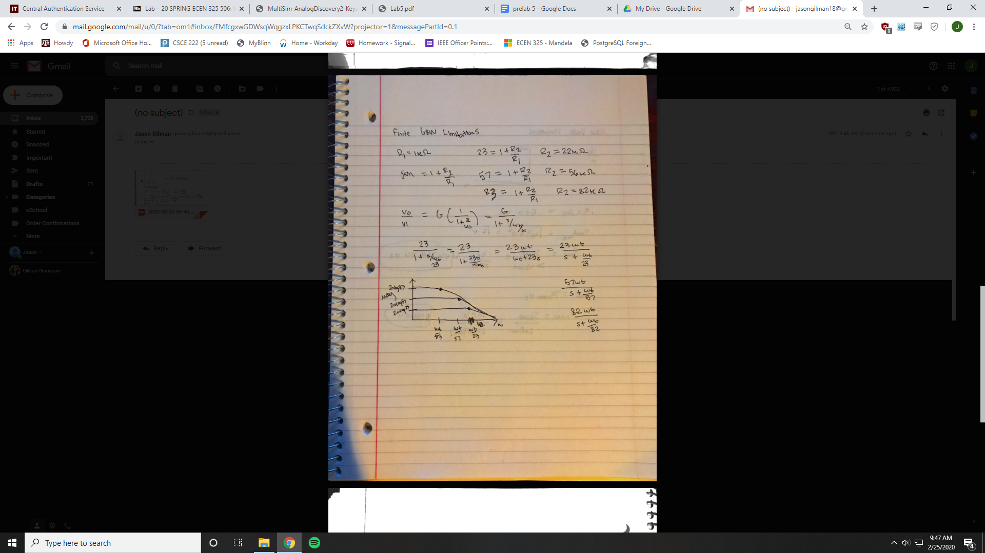

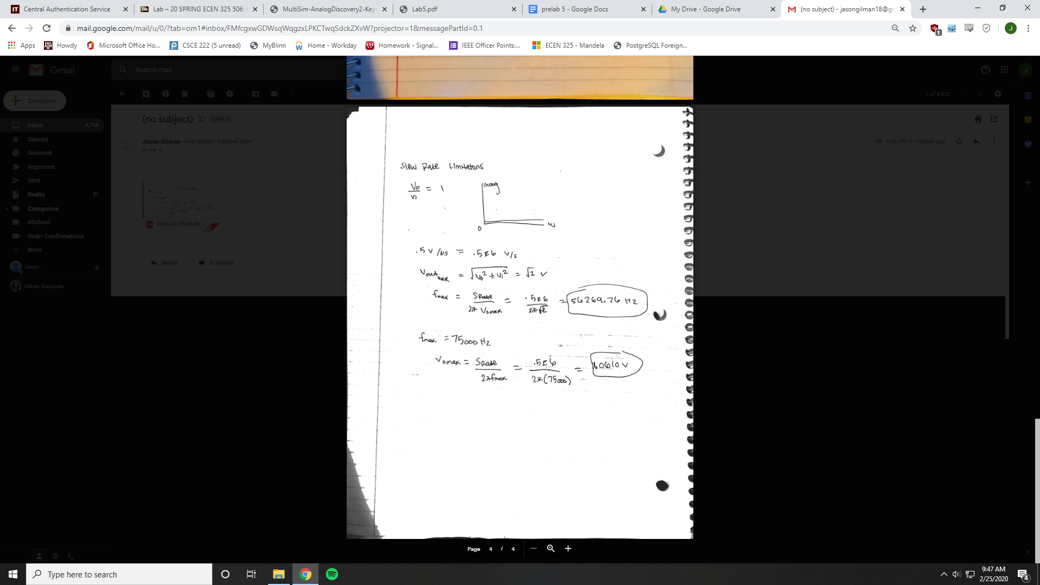

**Simulations:**

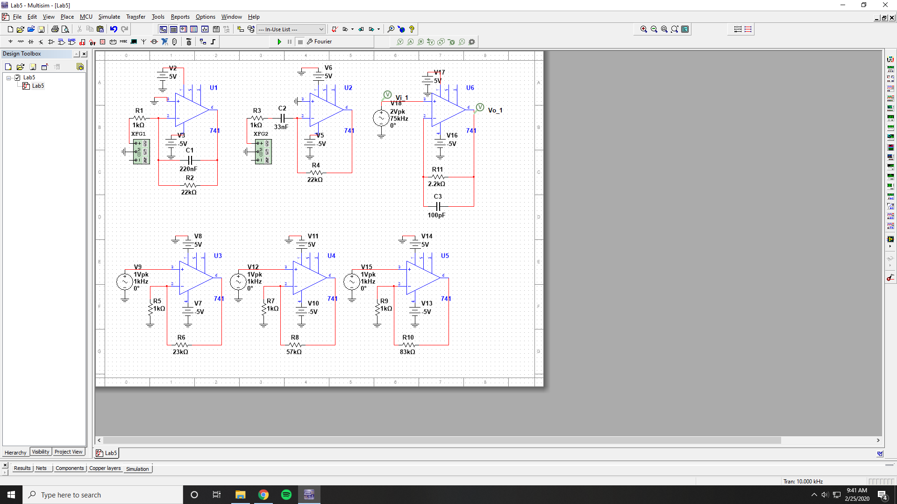

Lossy Integrator Bode Simulation

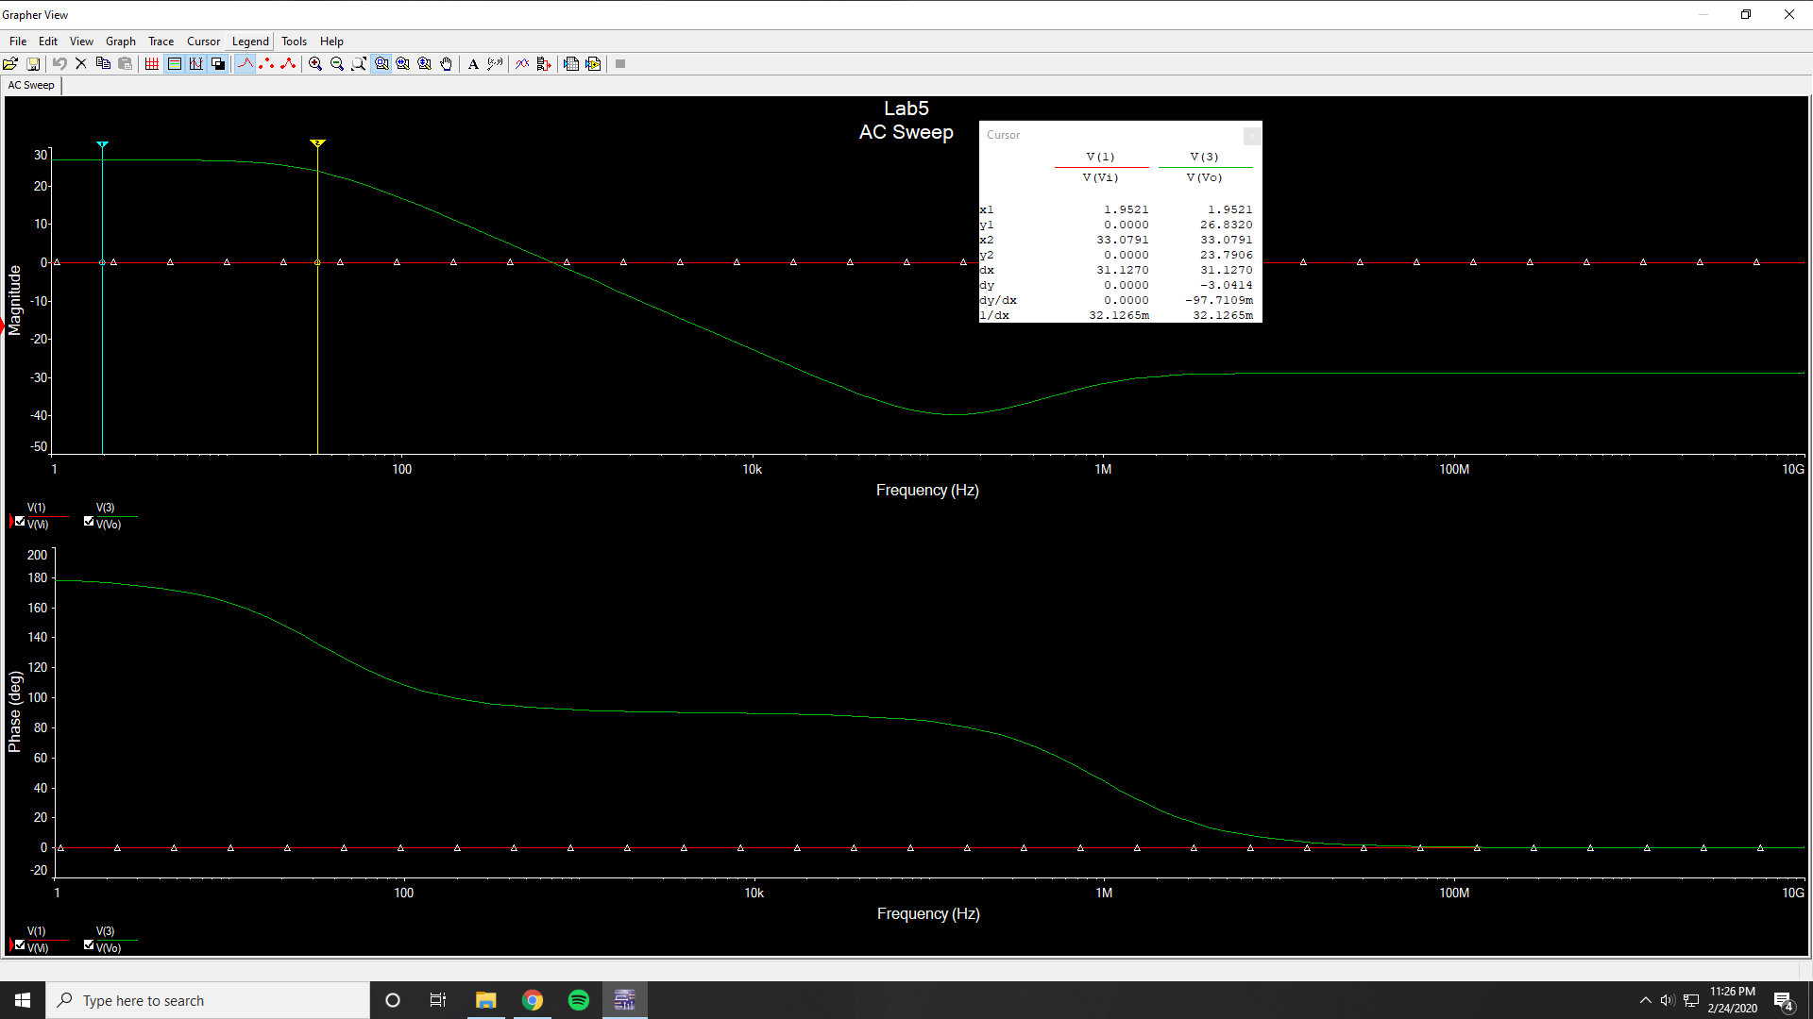

Low frequency gain = 26.8320 dB

3 dB frequency = 33.0791 Hz

1 kHz magnitude = 26.8320 dB

1 kHz phase = 178.25 °

Lossy Integrator Time-Domain Simulation

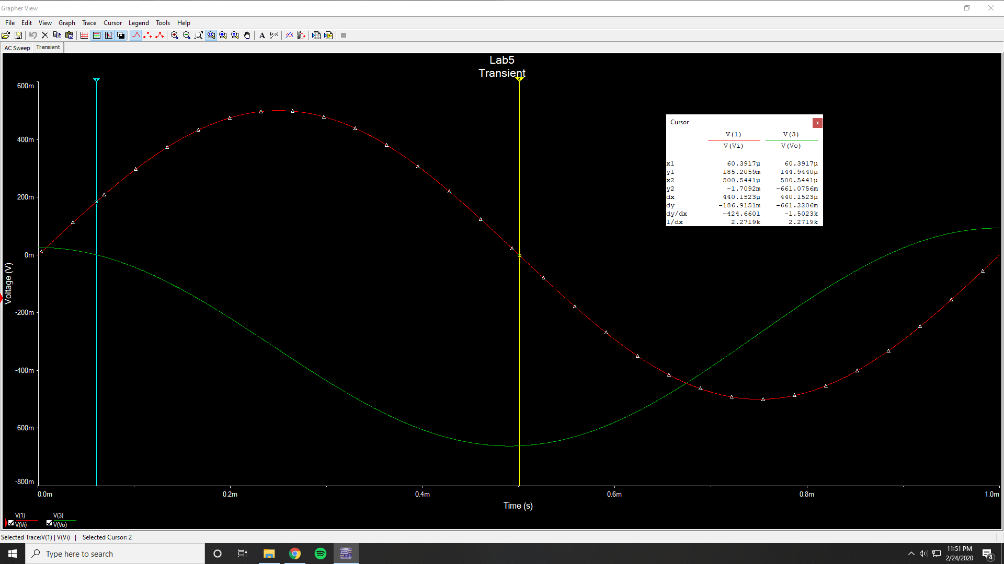

Vi Amplitude = 25.5433 mV

Vo Amplitude = 499.99 mV

Phase Difference = 158.063 °

Lossy Integrator Time-Domain Simulation (Square Wave)

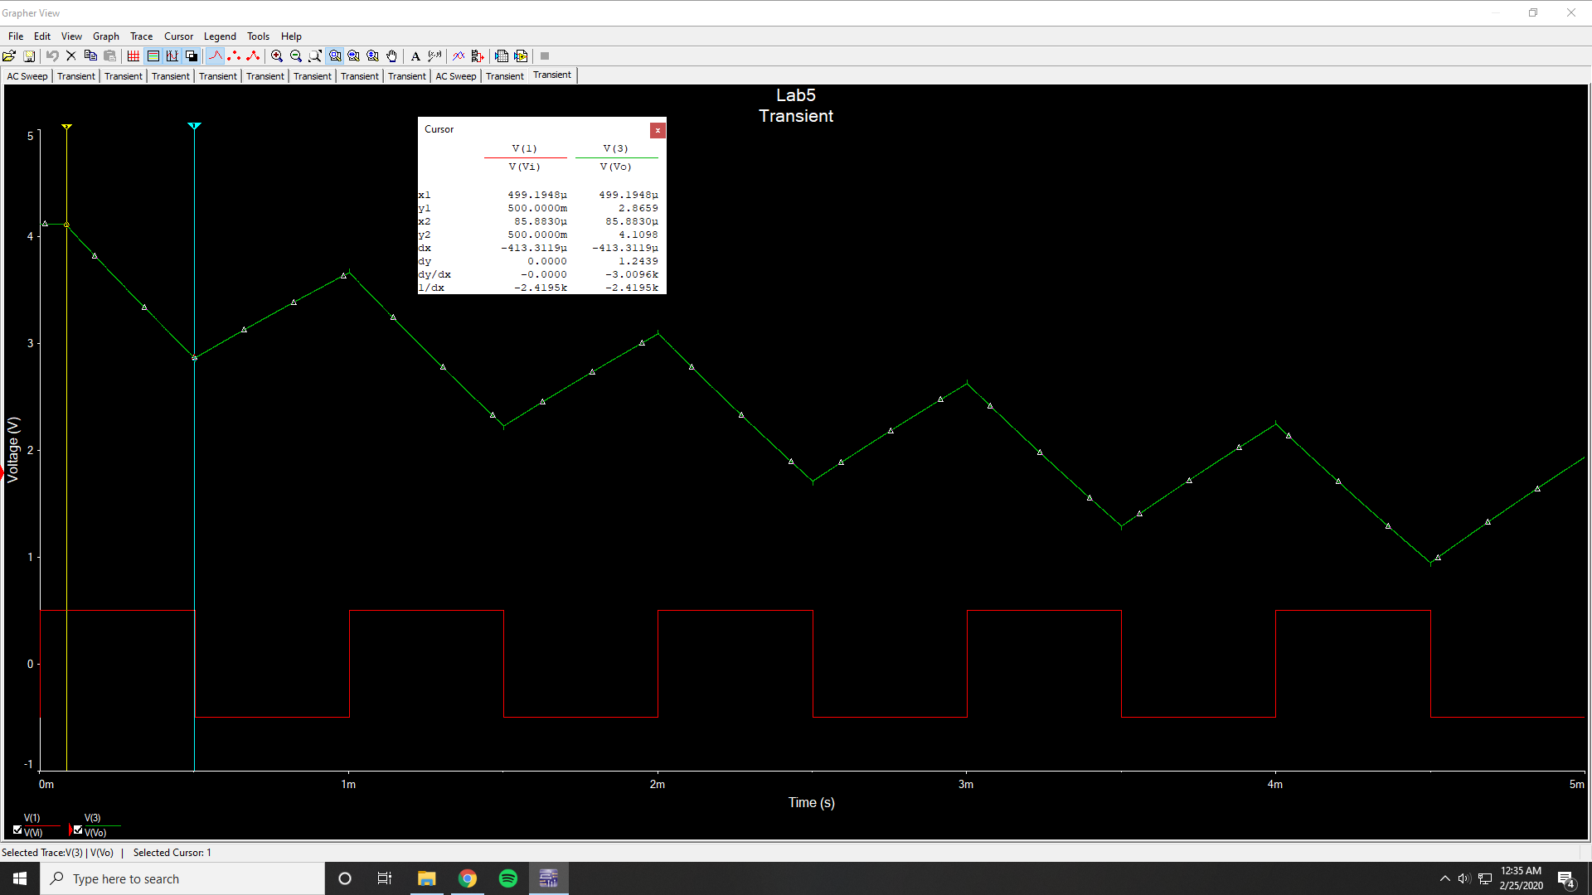

Vp2p = 1.2439 V

Pseudo Differential Bode Simulation

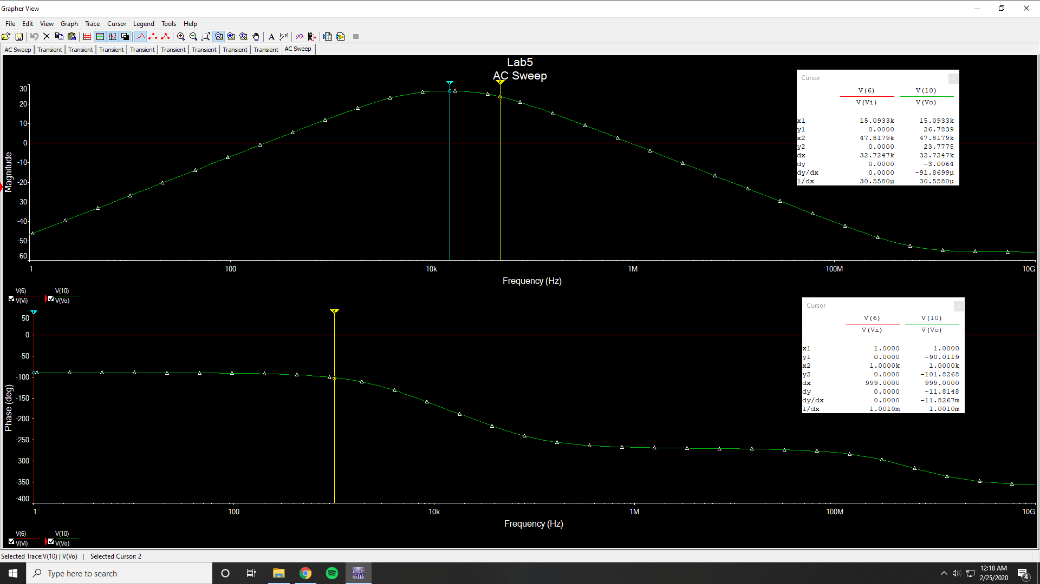

Low frequency gain = -63.0482 dB

3 dB frequency low = 4368 Hz

3 dB frequency high = 47817 Hz

1 kHz magnitude = 13.2338 dB

1 khz phase = -101.8268 °

Pseudo Differential Time-Domain Simulation

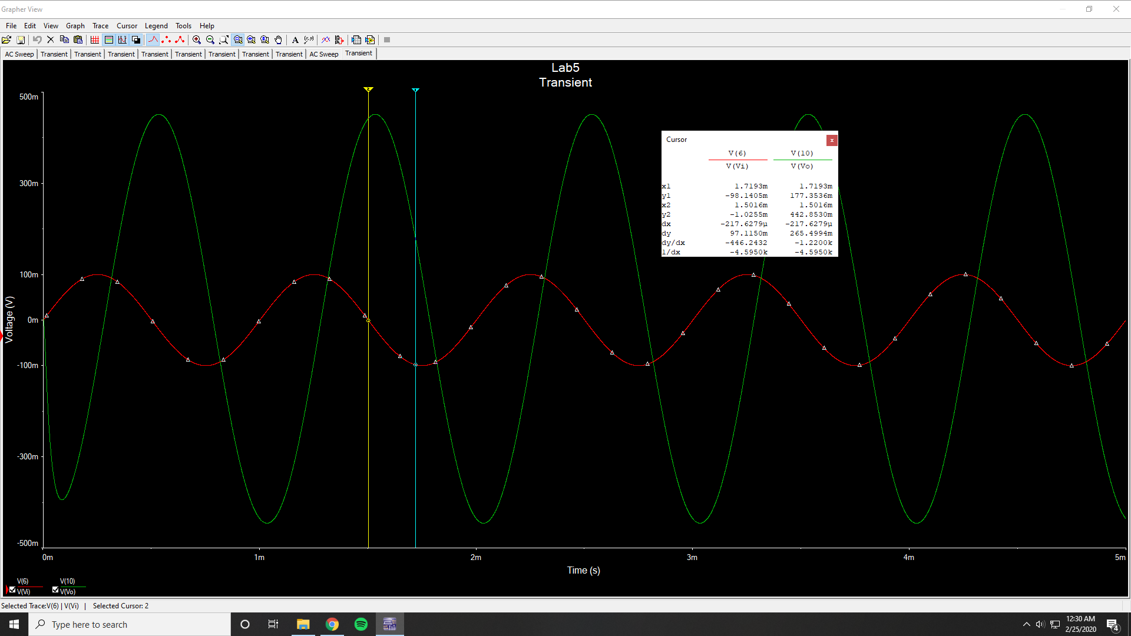

Vi Amplitude = 99.967 mV

Vo Amplitude = 451.4386 mV

Phase Difference = -79.308 °

Pseudo Differential Time-Domain Simulation (Triangular Wave)

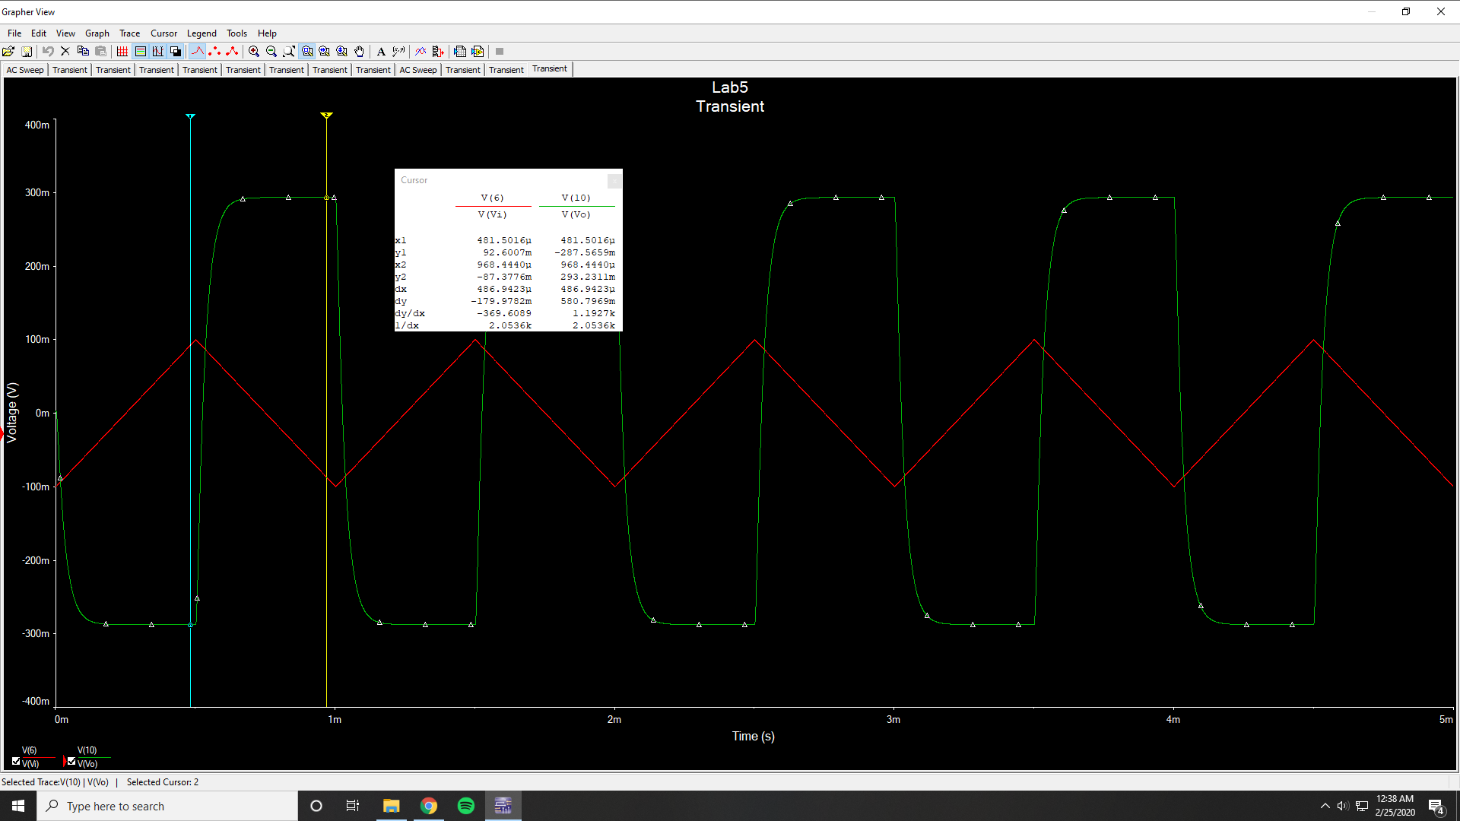

Vp2p = 580.7969 mV

Finite GBW Limitations Bode Simulation

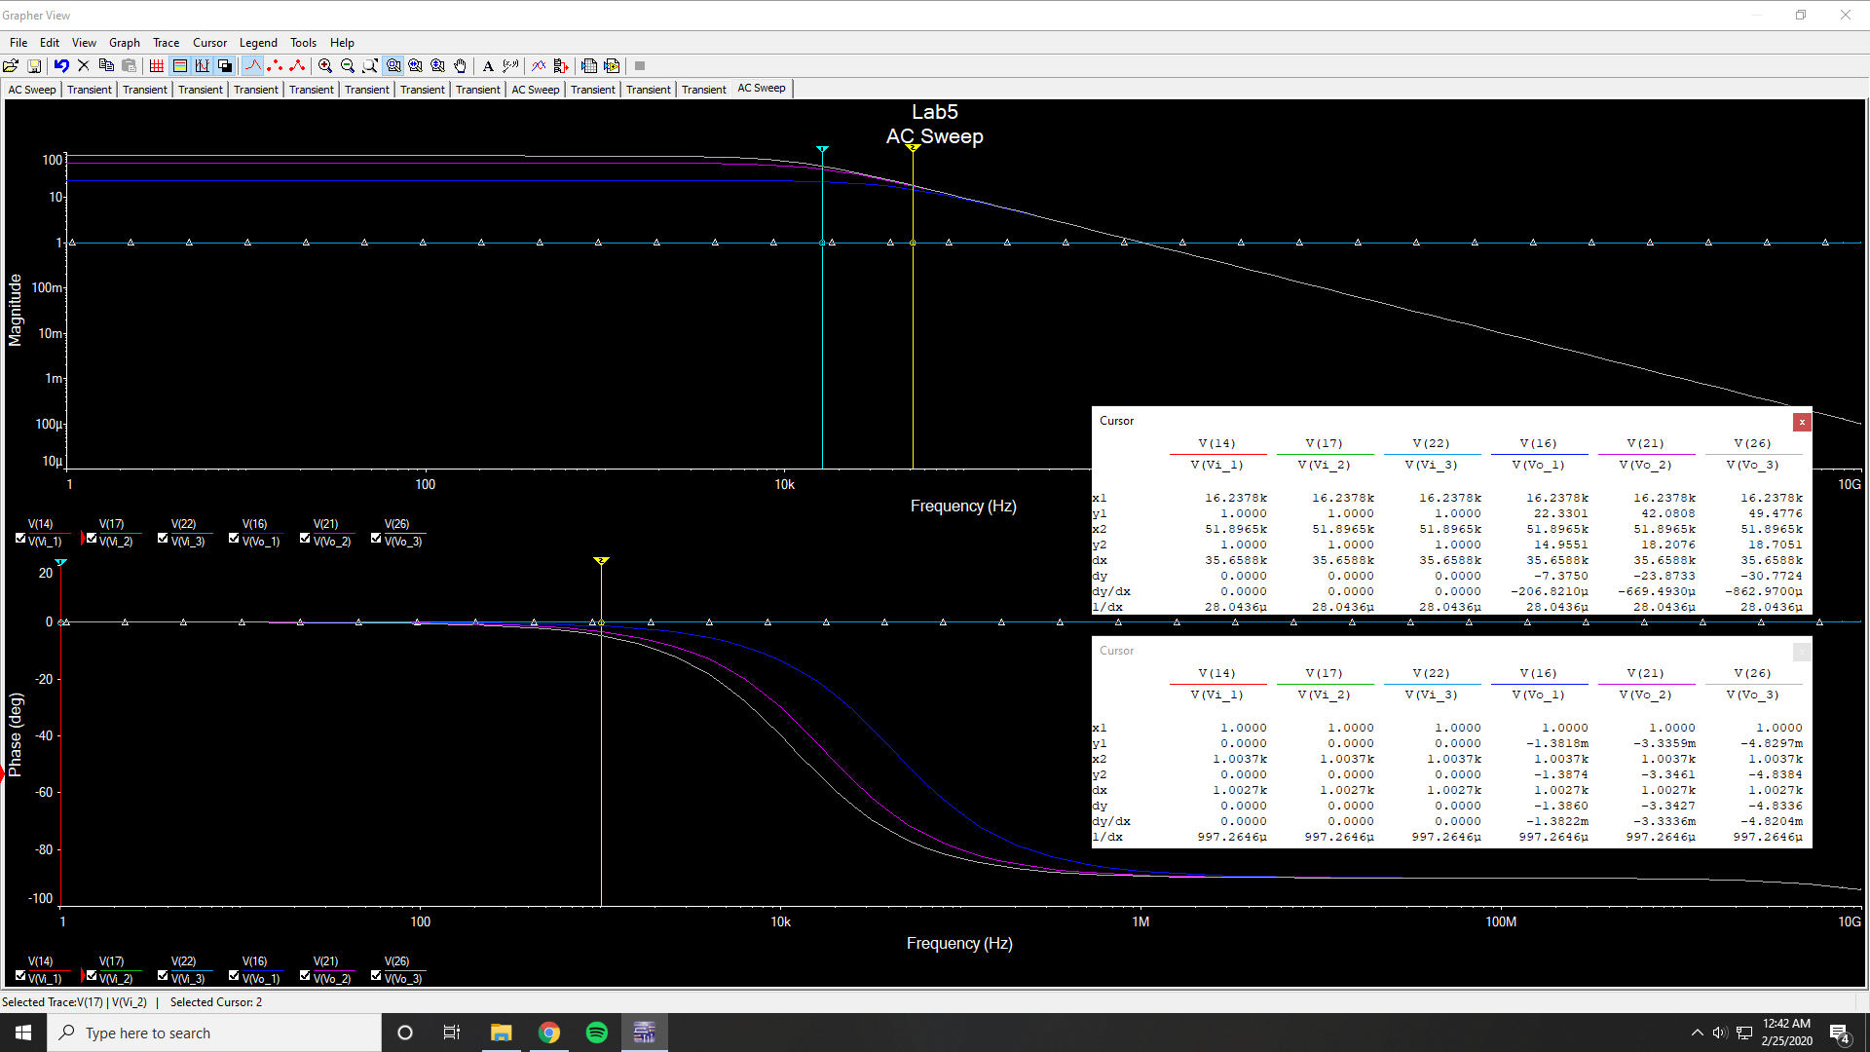

Low Frequency Gain @ 23 = 27.6029 dB

Low Frequency Gain @ 57 = 35.2658 dB

Low Frequency Gain @ 83 = 38.4817 dB

3 dB Frequency @ 23 = 41.325 kHz

3 dB Frequency @ 57 = 17.2917 kHz

3 dB Frequency @ 83 = 12.052 kHz

Slew Rate Limitations Bode Simulation

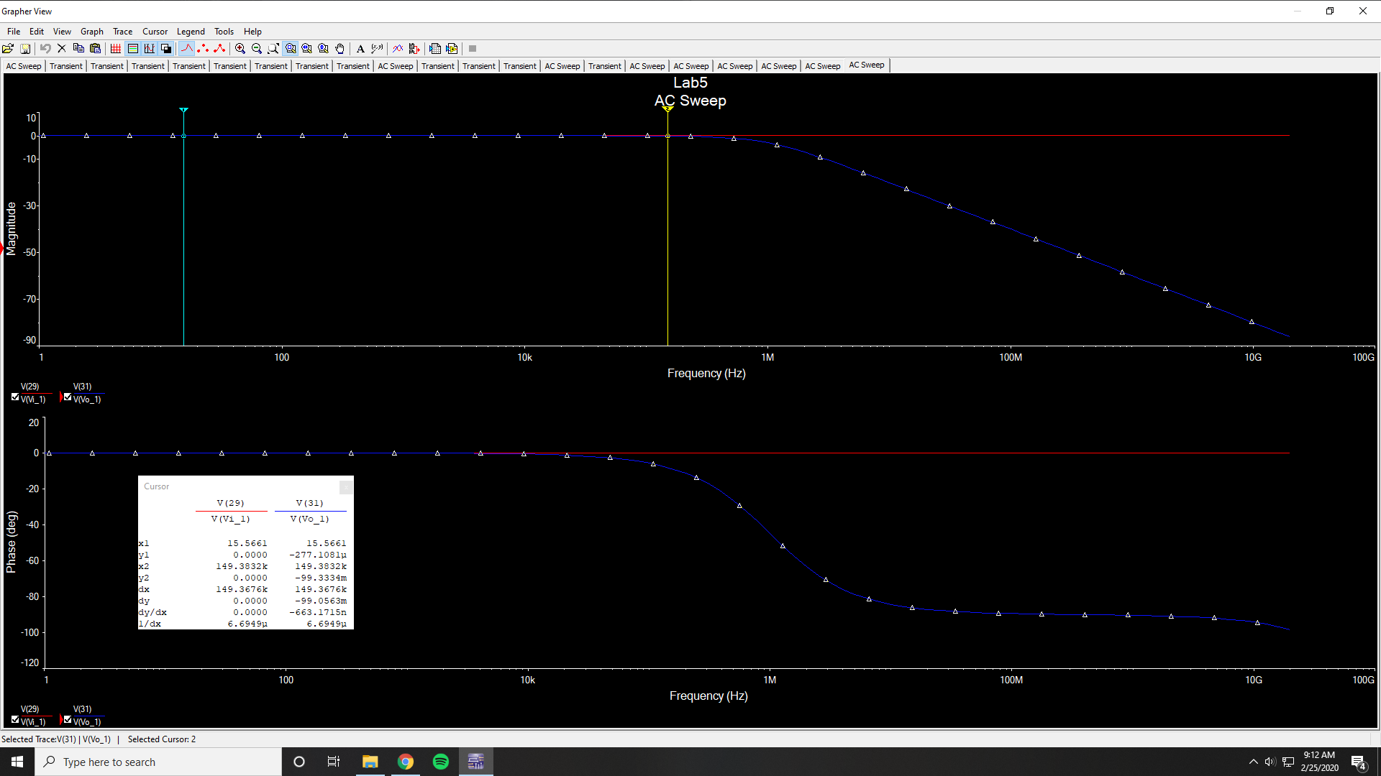

Low Frequency Gain = -277.1081 µdB

3 dB Frequency = 994.8678 kHz

75 kHz Magnitude = -25.9007 mdB

150 kHz Magnitude = -99.3334 mdB

Slew Rate Limitations Time-Domain Simulation (75 kHz 1V)

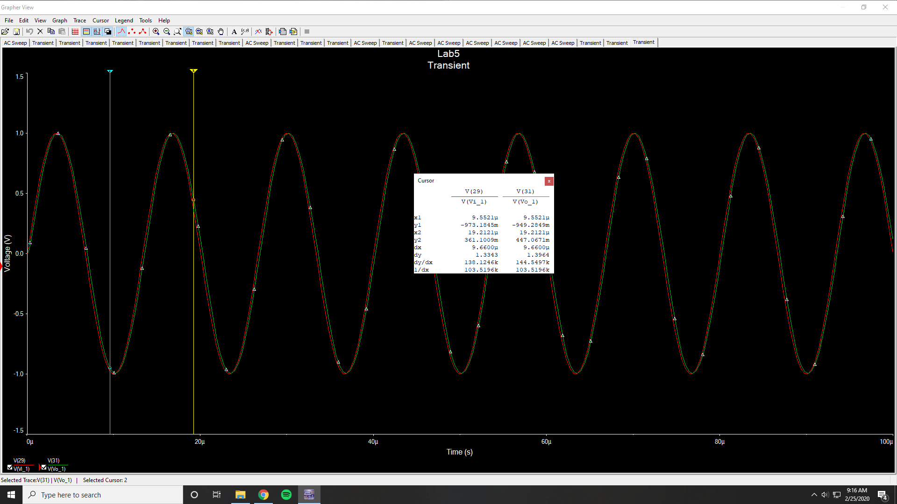

Slew Rate Limitations Fourier Simulation (75 kHz 1V)

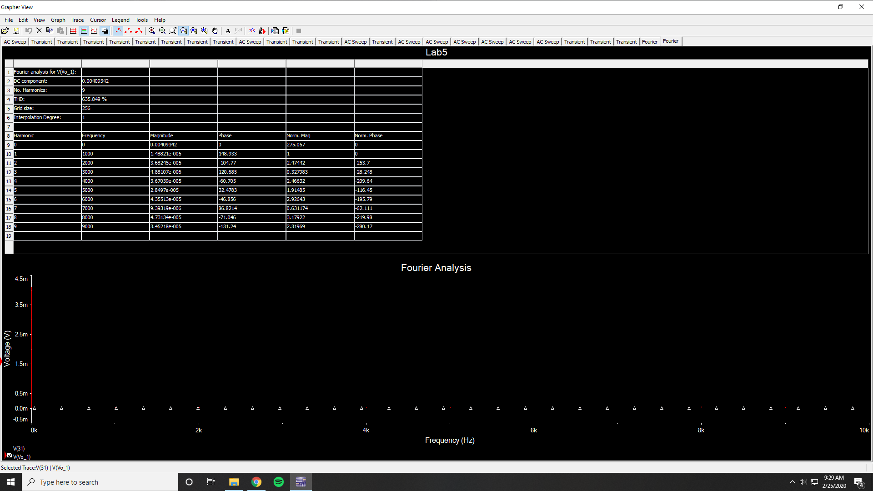

THD = 635.849 %

Slew Rate Limitations Time-Domain Simulation (75 kHz 2V)

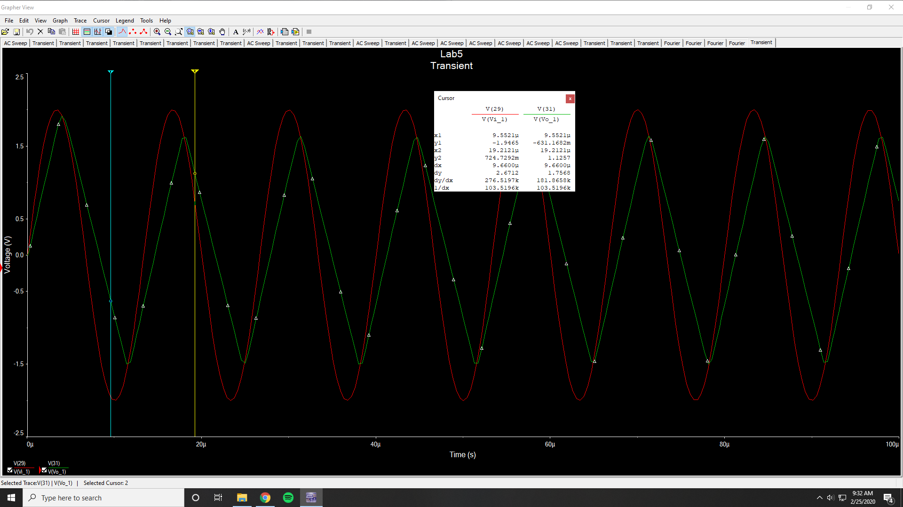

Slew Rate Limitations Fourier Simulation (75 kHz 2V)

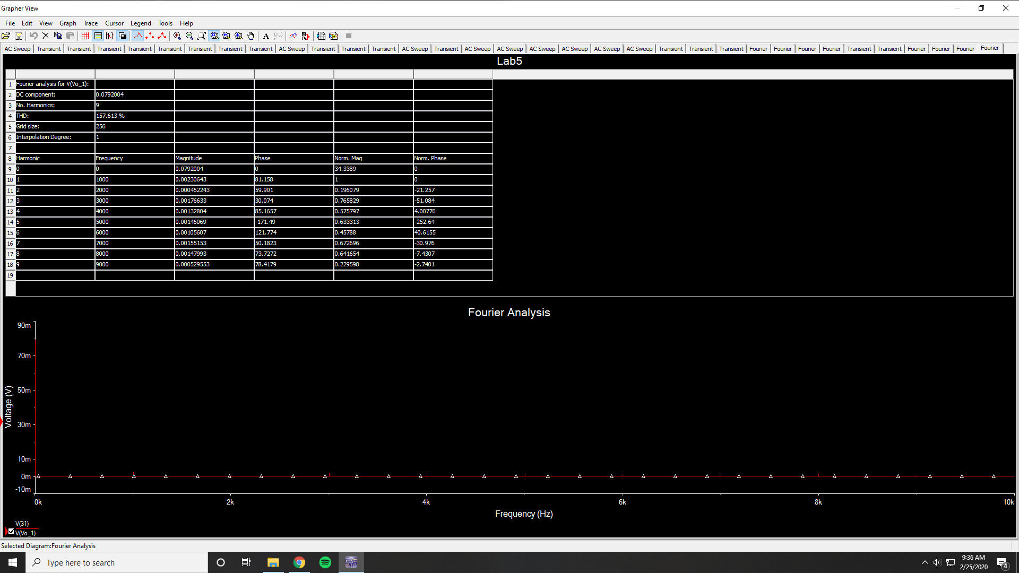

THD = 157.613 %

Slew Rate Limitations Time-Domain Simulation (150 kHz 1V)

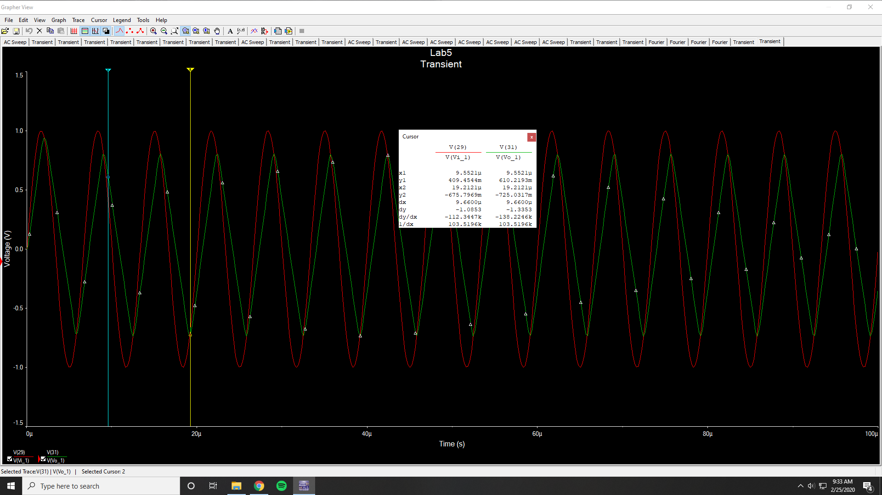

Slew Rate Limitations Fourier Simulation (150 kHz 1V)

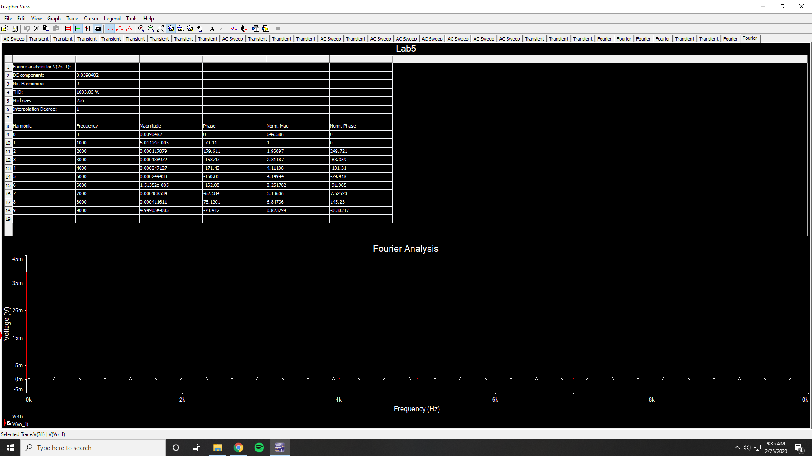

THD = 1003.86 %

**Measurements:**

Lossy Integrator Bode Plot Measurement

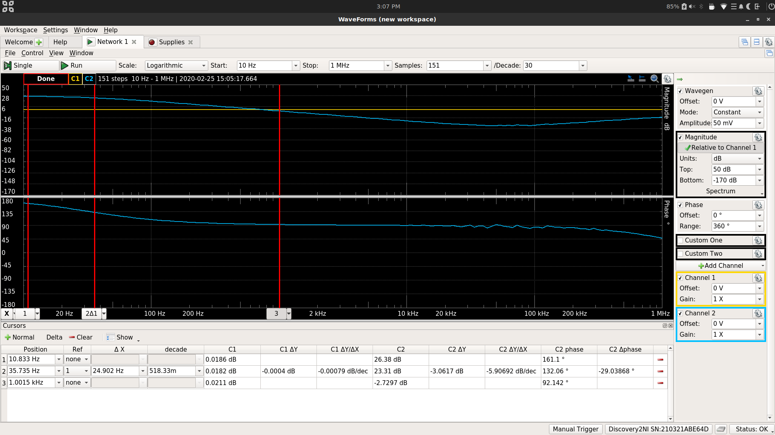

Low Frequency Gain = 26.38 dB

3-dB Frequency = 35.735 Hz

Magnitude 1 kHz = -2.7297 dB

Phase 1 kHz = 92.142°

Lossy Integrator Time-Domain Plot Measurement (1kHz 500mV Sine input)

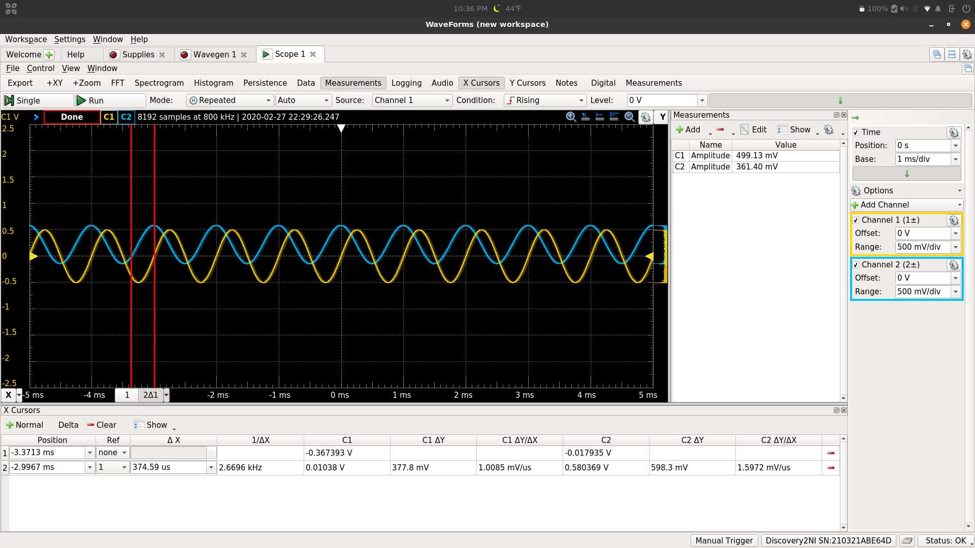

Vi Amplitude = 499.13 mV

Vo Amplitude = 361.4 mV

Phase Difference = 134.856°

Lossy Integrator Time-Domain Plot Measurement (1kHz 500mV Square input)

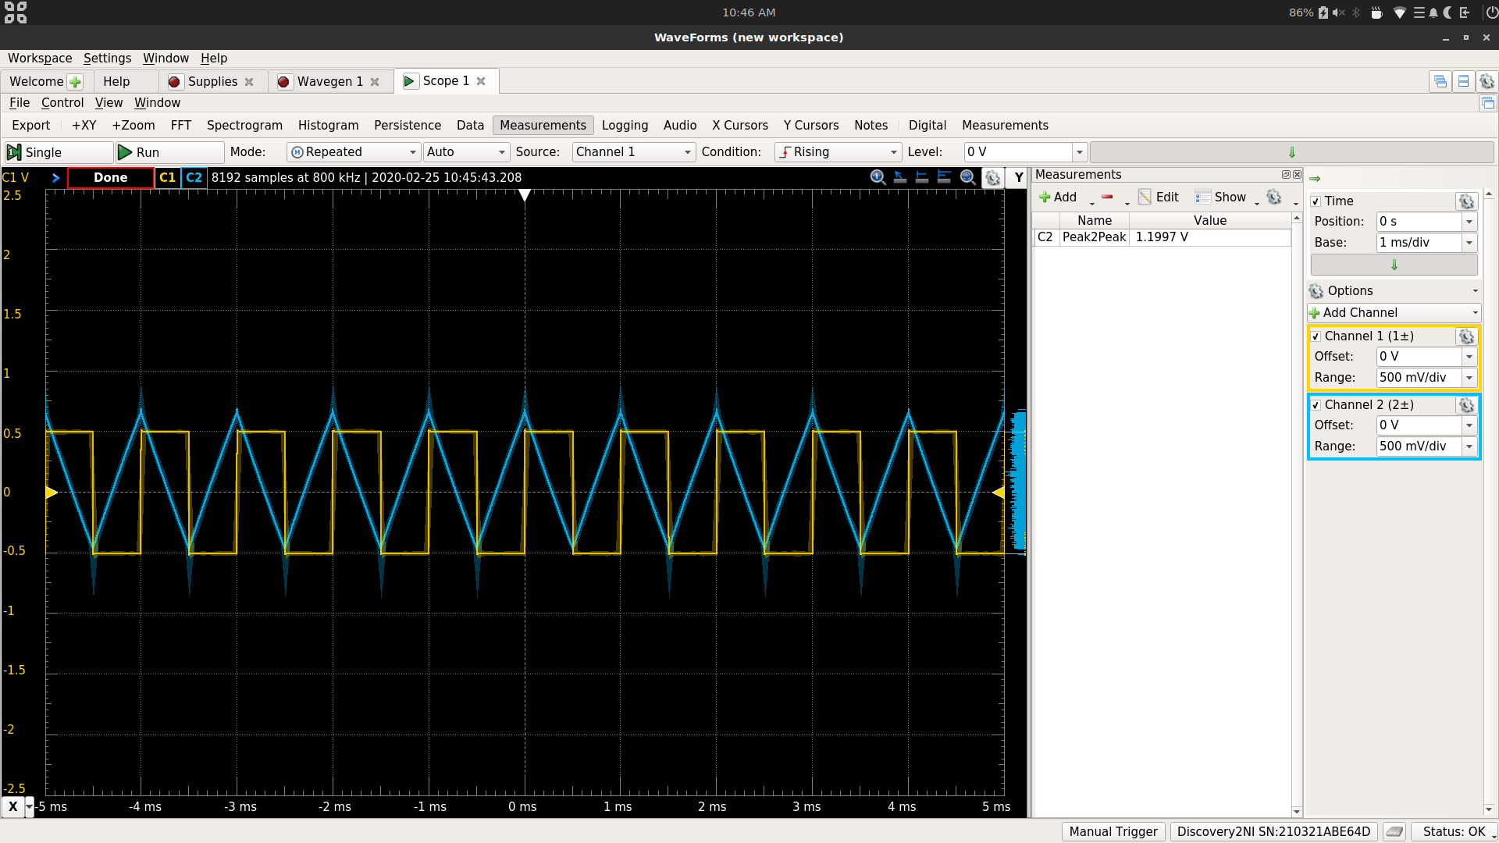

Vo P2P = 1.1997 V

Lossy Integrator Without R2

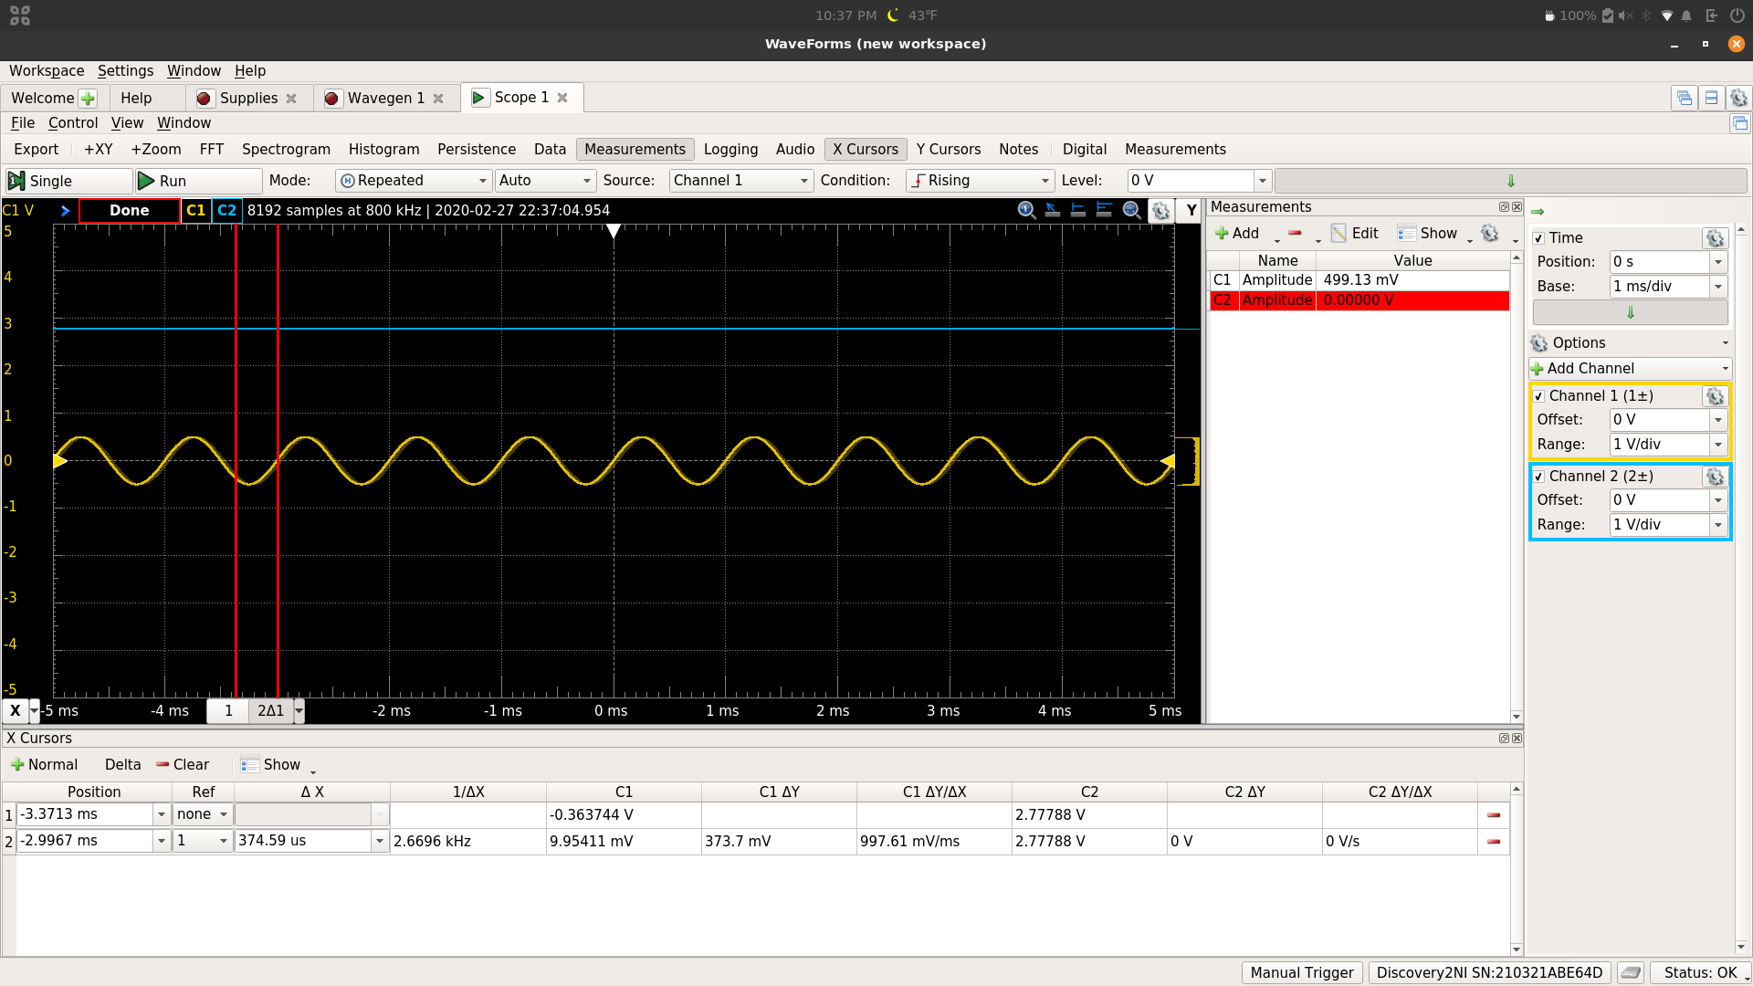

Vo becomes a constant voltage value, approximately 2.77 V.

Pseudo Differentiator Bode Plot Measurement

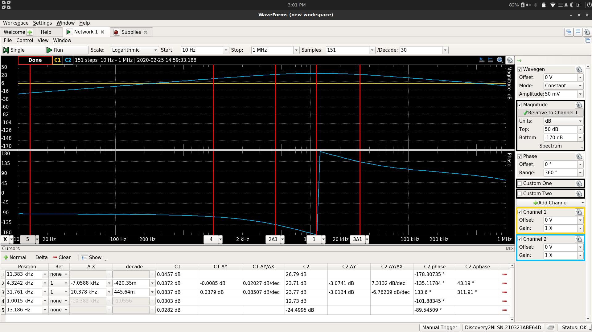

Low Frequency Gain = -24.4995 dB

3-dB Frequency Low = 4.3242 kHz

3-dB Frequency High = 31.761 kHz

Magnitude 1 kHz = 12.73 dB

Phase 1 kHz = -101.88345

Pseudo Differentiator Time-Domain Plot Measurement (1 kHz 100 mV Sine input)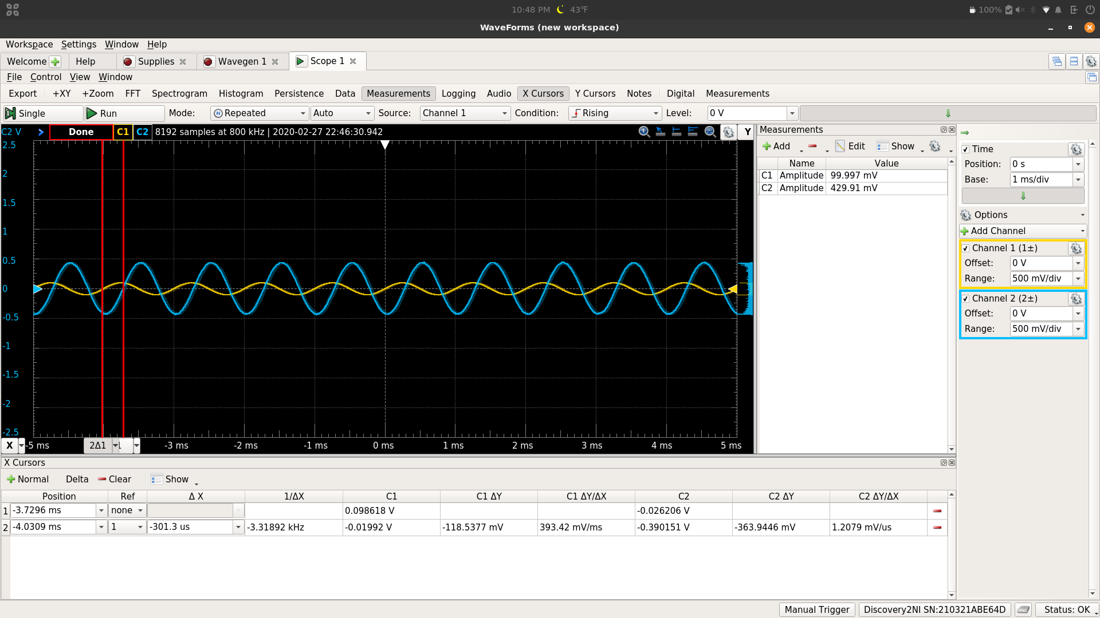

Vi Amplitude = 99.997 mV

Vo Amplitude = 429.91 mV

Phase Difference = -108.468

Pseudo DIfferentiator Time-Domain Plot Measurement (1 kHz 100 mV Triangle input)

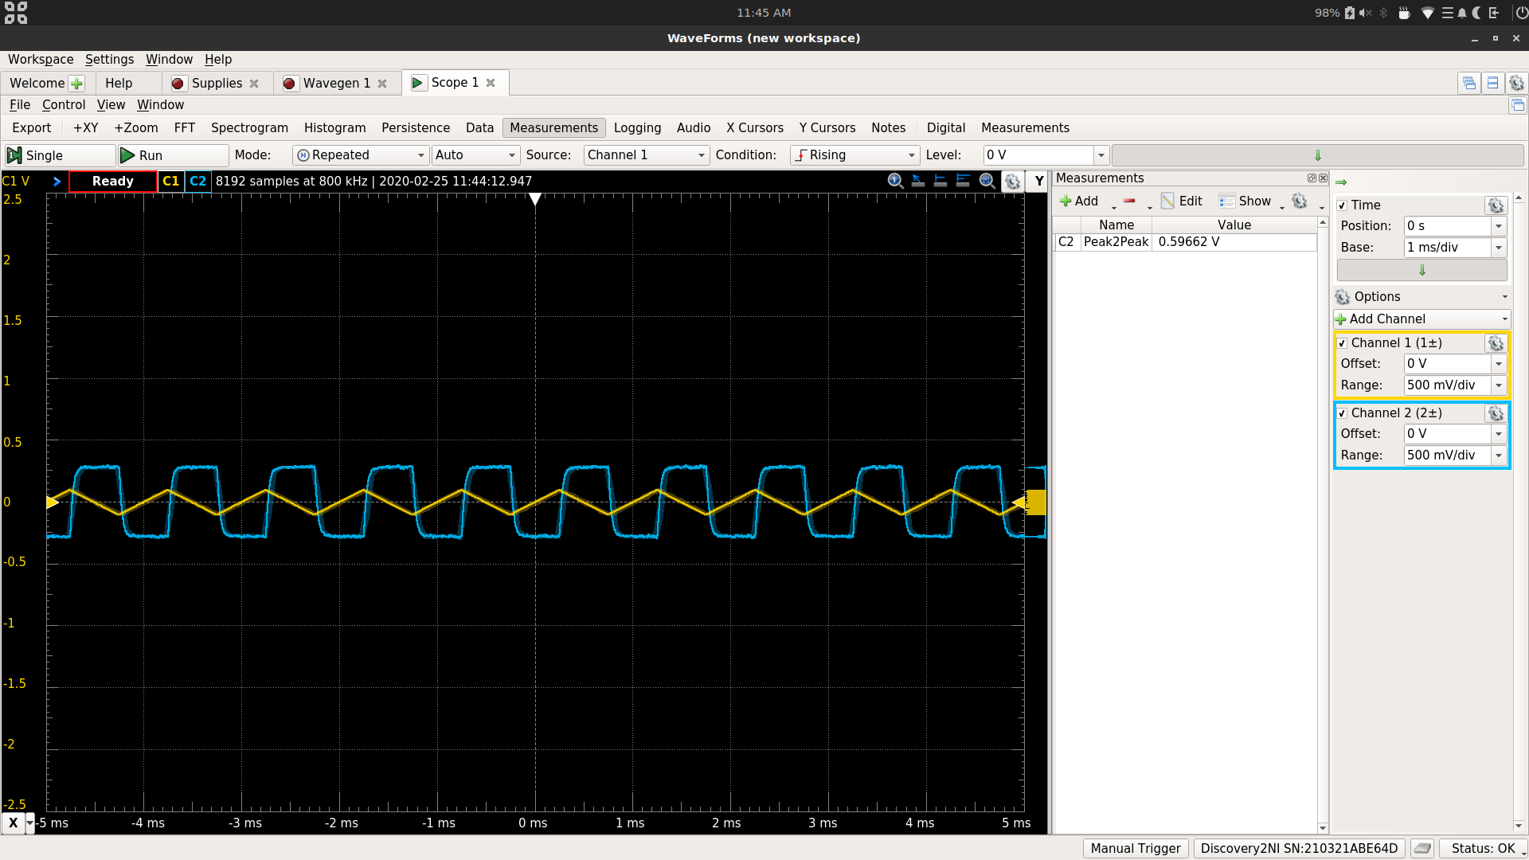

Vo P2P = .59662 V

Non-Inverting Amplifier Bode Plot Measurement (G = 23)

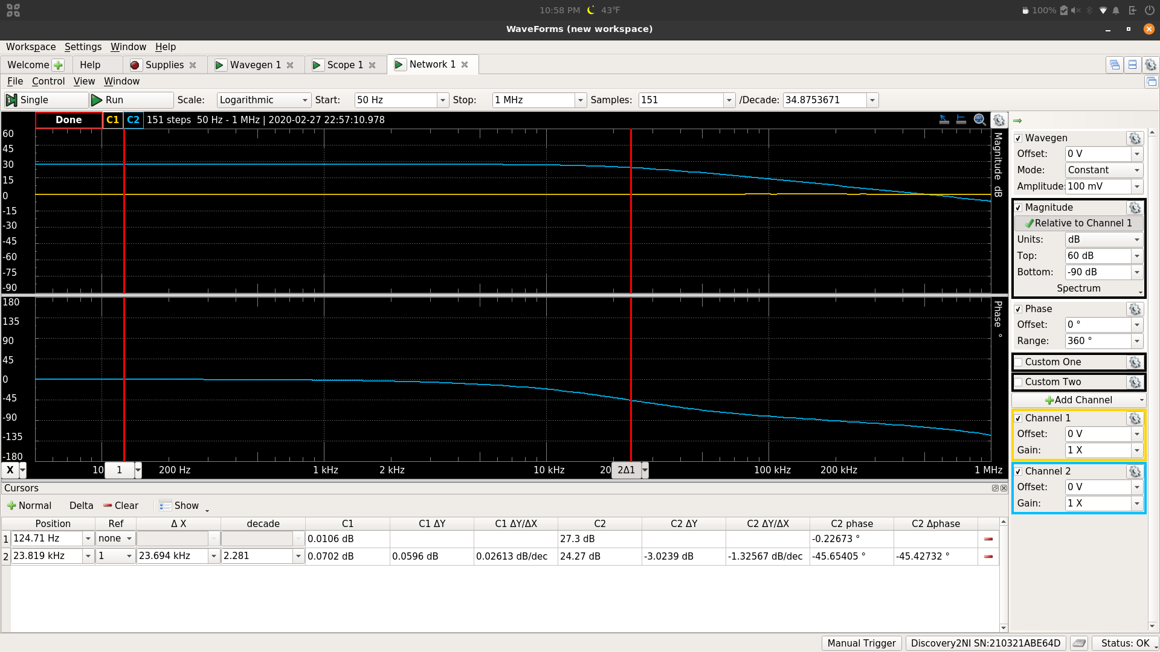

Low Frequency Gain = 27.3 dB

3-dB Frequency = 23.819 kHz

Non-Inverting Amplifier Bode Plot Measurement (G = 57)

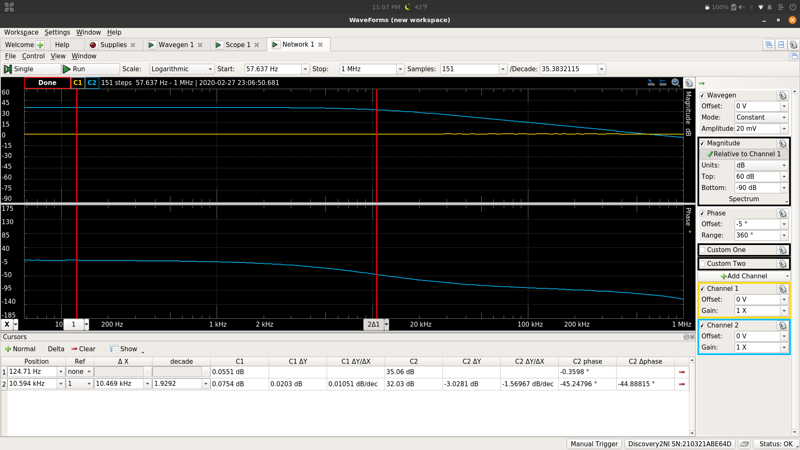

Low Frequency Gain = 35.06

3-dB Frequency = 10.594 kHz

Non-Inverting Amplifier Bode Plot Measurement (G = 83)

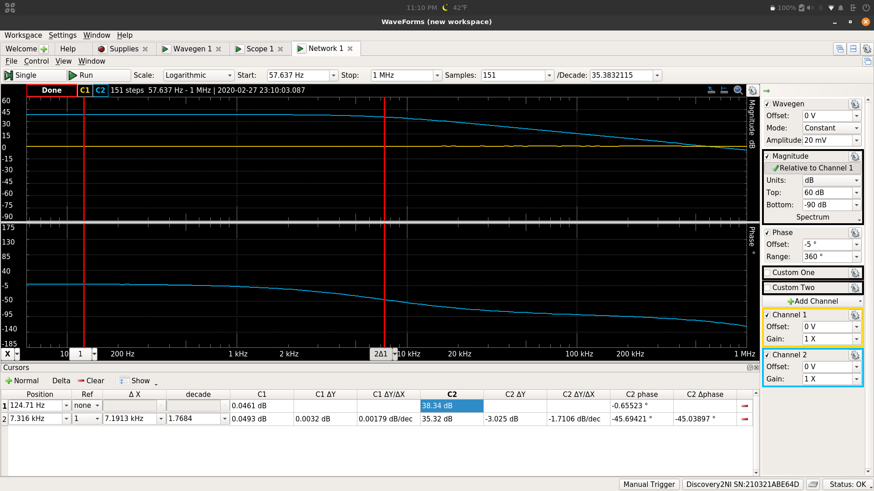

Low Frequency Gain = 38.34 dB

3-dB Frequency = 7.316 kHz

Unity Gain Bode Plot Measurement

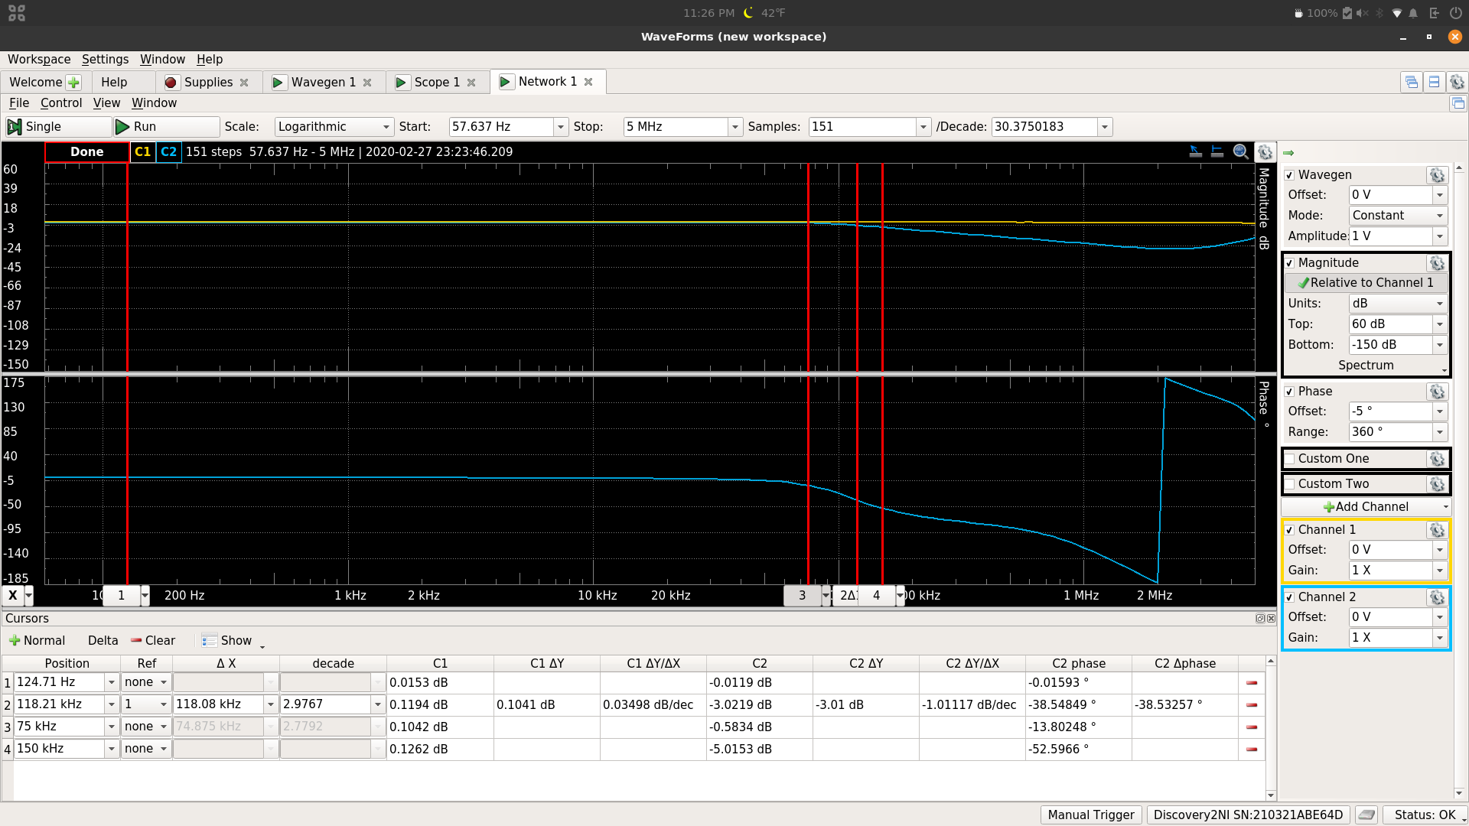

Low Frequency Gain = -.0119 dB

3-dB Frequency = 118.21 kHz

Magnitude 75 kHz = -.5834 dB

Magnitude 150 kHz = -5.0153 dB

Unity Gain TIme-Domain Plot Measurement (75 kHz 1 V Sine Input)

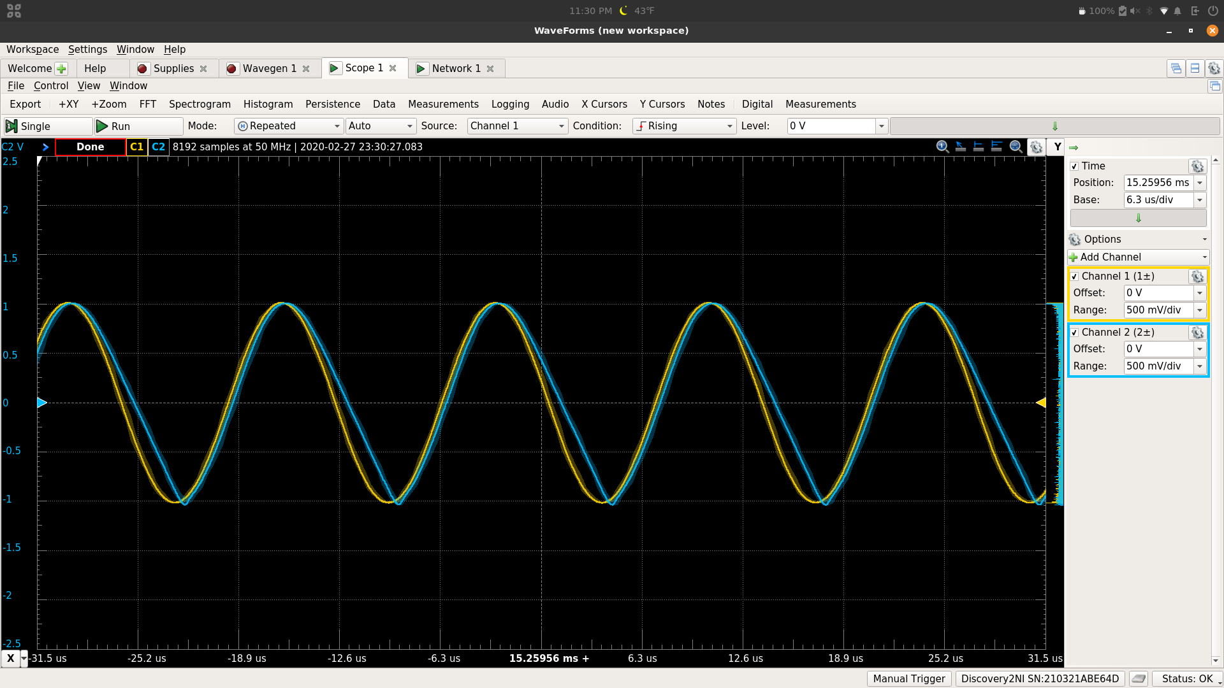

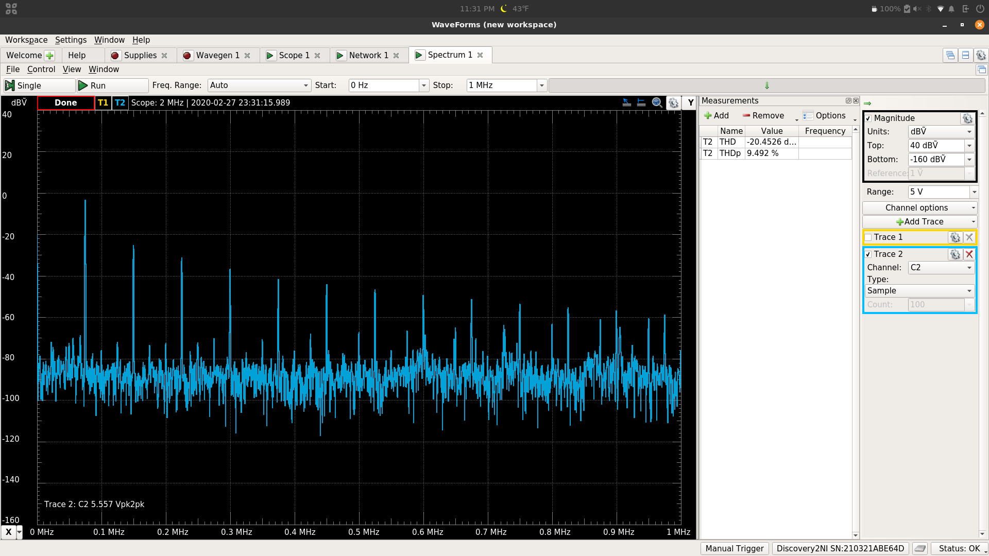

THD = 9.492%

Unity Gain Time-Domain Plot Measurement (75 kHz 2 V Sine Input)

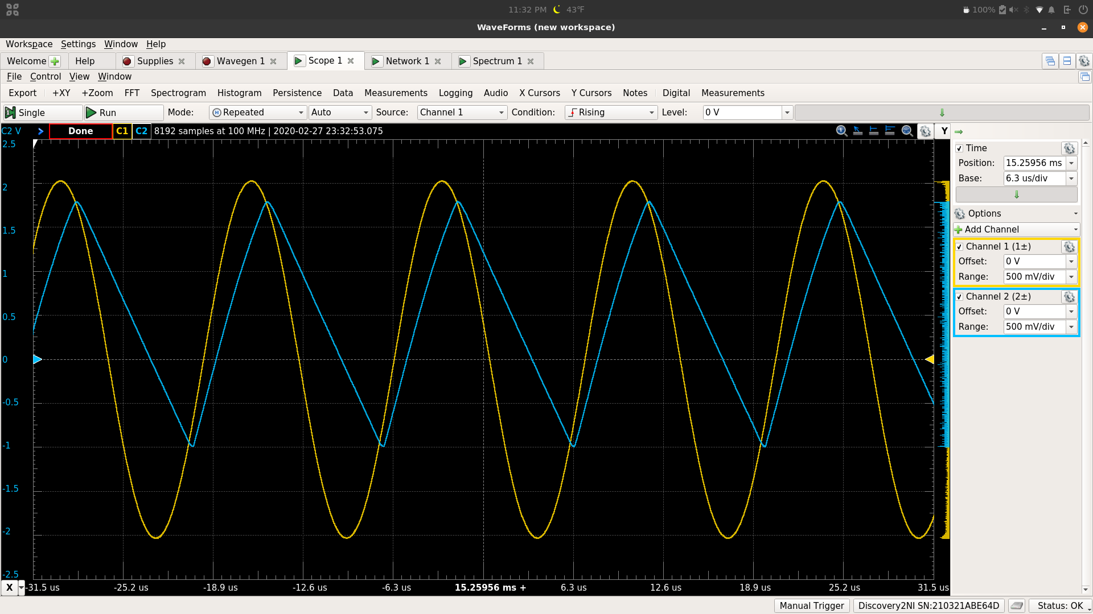

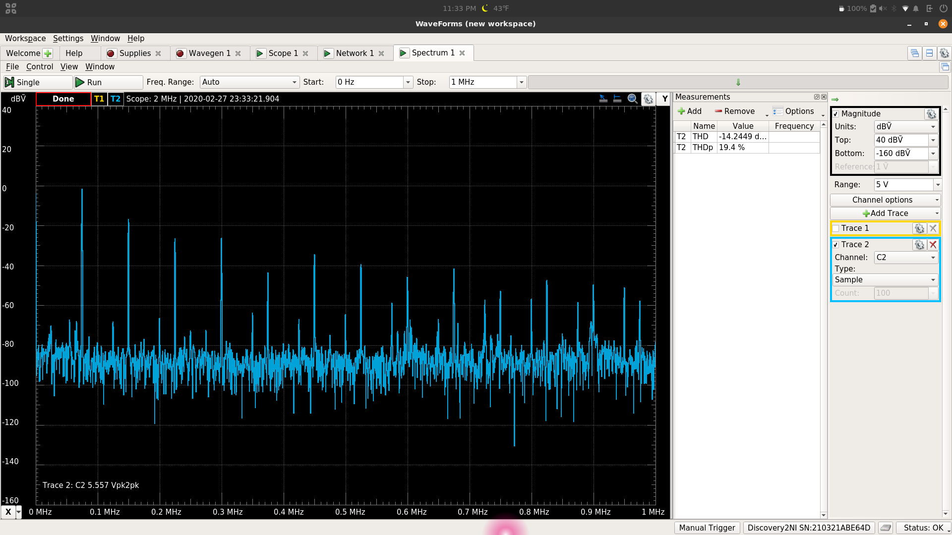

THD = 19.4 %

Unity Gain Time-Domain Plot Measurement (150 kHz 1 V Sine Input)

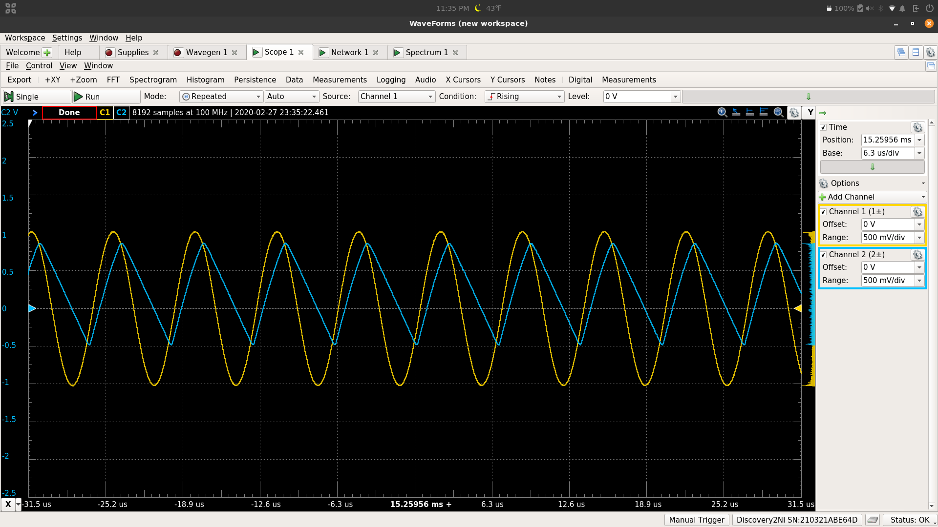

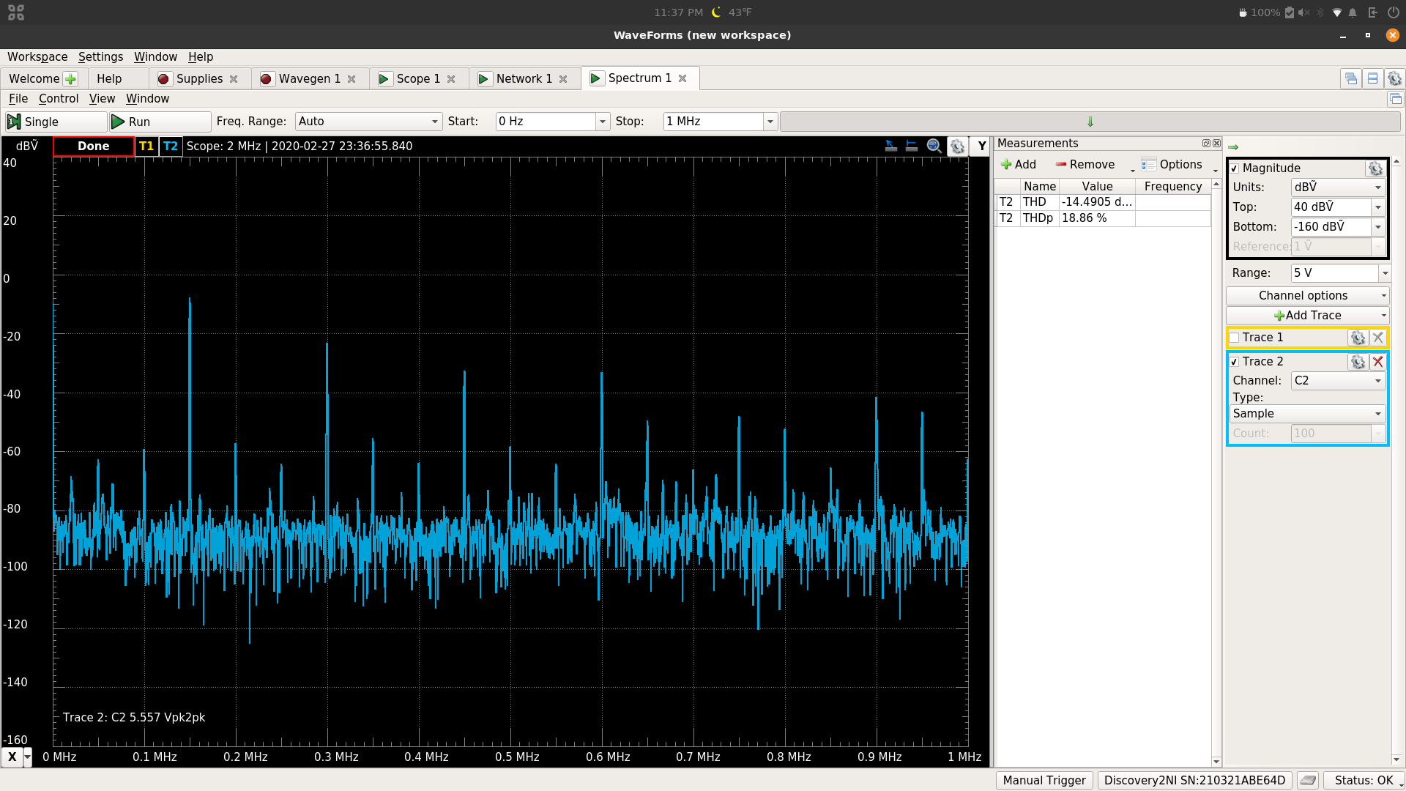

THD = 18.86 %

|  |  |  |  |
| --- | --- | --- | --- |
|  | Simulated | Measured | Calculated |
| Low Frequency Gain, Lossy Integrator | 26.8320 dB | 26.38 dB | - |
| 3-dB Frequency, Lossy Integrator | 33.0791 Hz | 35.735 Hz | 4.75206 kHz |
| Magnitude 1 kHz,  Lossy Integrator | 26.8320 dB | -2.7297 dB | - |
| Phase 1 kHz,  Lossy Integrator | 178.25 ° | 92.142° | - |
| Vi Amplitude,  Lossy Integrator | 25.5433 mV | 499.13 mV | - |
| Vo Amplitude,  Lossy Integrator | 499.99 mV | 361.4 mV | - |
| Phase Difference,  Lossy Integrator | 158.063 ° | 134.856° | - |
| P2P,  Lossy Integrator | 1.2439 V | 1.1997 V | - |
| Low Frequency Gain, Pseudo Differentiator | -63.0482 dB | -24.4995 dB | - |
| 3-dB Frequency, Pseudo Differentiator | Low : 4.368 kHz  High: 47.817 kHz | Low: 4.3242 kHz  High: 31.761 kHz | 1.3175 kHz |
| Magnitude 1kHz,  Pseudo Differentiator | 13.2338 dB | 12.73 dB | - |
| Phase 1kHz,  Pseudo Differentiator | -101.8268 ° | -101.88345° | - |
| Vi Amplitude,  Pseudo Differentiator | 99.967 mV | 99.997 mV | - |
| Vo Amplitude,  Pseudo Differentiator | 451.4386 mV | 429.91 mV | - |
| Phase Difference,  Pseudo Differentiator | -79.308 ° | -108.468° | - |
| P2P,  Pseudo Differentiator | 580.7969 mV | .59662 V | - |
| Low Frequency Gain,  Non-Inverting, 23 | 27.6029 dB | 27.3 dB | - |
| 3-dB Frequency,  Non-Inverting, 23 | 41.325 kHz | 23.819 kHz | - |
| Low Frequency Gain,  Non-Inverting, 57 | 35.2658 dB | 35.06 dB | - |
| 3-dB Frequency,  Non-Inverting, 57 | 17.2917 kHz | 10.594 kHz | - |
| Low Frequency Gain,  Non-Inverting, 83 | 38.4817 dB | 38.34 dB | - |
| 3-dB Frequency,  Non-Inverting, 83 | 12.052 kHz | 7.316 kHz | - |
| Low Frequency Gain,  Unity Gain | -277.1081 µdB | -.0119 dB | - |
| 3-dB Frequency,  Unity Gain | 994.8678 kHz | 118.21 kHz | - |
| Magnitude 75 kHz,  Unity Gain | -25.9007 mdB | -.5834 dB | - |
| Magnitude 150 kHz,  Unity Gain | -99.3334 mdB | -5.0153 dB | - |
| THD,  Unity Gain,  75 kHz 1 V | 635.849 % | 9.492% | - |
| THD,  Unity Gain,  75 kHz 2 V | 157.613 % | 19.4 % | - |
| THD,  Unity Gain,  150 kHz 1 V | 1003.86 % | 18.86 % | - |

**Conclusion:**

Looking at the data, most of the simulations reflect the measurements. Although, there are some differences in the values. I think some of the differences could be reflected in the voltage input amplitude. This value needed to be lowered for many of the calculations on the bode plot measurements, which may have affected some of the output measurements.